LEVEL 2, WEEK 1
STUDENT PACKET

ACTIVITY ONE:
Write a paragraph introducing and describing yourself using the verb “to be.”

________________________________________________________________________________________________________________________________________________________________________________________________________________________________________________________________________________________________________________________________

ACTIVITY TWO:
FORMING QUESTIONS
Change the sentences into questions.

1.) She is happy.
____________________________________________________________

2.) They want apples.
____________________________________________________________

3.) We like that restaurant.

____________________________________________________________

4.) You have an extra pencil.
____________________________________________________________

5.) I have homework for my English class.
____________________________________________________________

6.) He is sad today.

____________________________________________________________

7.) You are tired.
____________________________________________________________

8.) The dogs are friendly.
____________________________________________________________

ACTIVITY THREE:
NUMBERS
Write the complete spelling of each number.

52 | 11
100 | 26
93 | 0
84 | 75
40 | 18
39 | 21
27 | 63

ACTIVITY FOUR:
“HOW MUCH/HOW MANY”
Look at the picture.
Decide if the object in the picture is a countable noun or an uncountable noun.
Decide if you should say “how much” or “how many” for the object in the picture.
Write a question for the object in the picture. Example: How many trees are there?
Write the answer to the question.


Circle one: COUNTABLE UNCOUNTABLE

Circle one: HOW MANY HOW MUCH

Question: _________________________________________________

Answer:

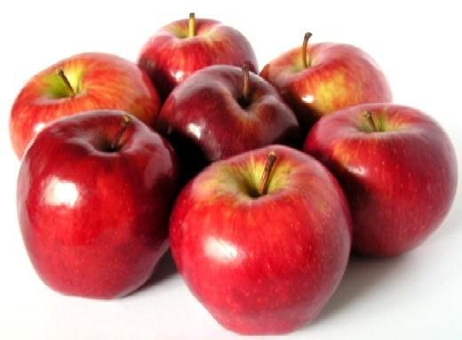
Circle one: COUNTABLE UNCOUNTABLE

Circle one: HOW MANY HOW MUCH

Question:

Answer:


Circle one: COUNTABLE UNCOUNTABLE

Circle one: HOW MANY HOW MUCH

Question:

Answer:

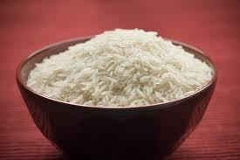
Circle one: COUNTABLE UNCOUNTABLE

Circle one: HOW MANY HOW MUCH

Question:

Answer: ________

Choose the right word:

- We don’t have that many/much potatoes.
- I bought so many/much sugar yesterday.
- She has so many/much children to take care of.
- How many/much rice did you buy?
- How many/much does this cost?
- How many/much time is left in class?

ACTIVITY FIVE:
“THERE IS/THERE ARE”
Change the statements to questions and change the questions to statements. Add “is” or “are” depending on what fits in the sentence.

Examples:
___ there dogs in your house?
There are dogs in your house.

There ___ a spider in my room.
Is there a spider in my room?

1.) ___ there a computer in the library?

________________________________________________________________________________________________

2.) There ___ clothes on the floor.

________________________________________________________________________________________________

3.) ___ there children in her neighborhood?

________________________________________________________________________________________________

4.) There ___ a lot of snow outside.

________________________________________________________________________________________________

ACTIVITY SIX:
CITY PLACES
Match the English and Spanish words.

Airport El cine

Gym La farmacia

Museum La gasolinera

Bookstore La librería

Hair salon El hospital

Pharmacy El aeropuerto

Bank La biblioteca

Hospital El supermercado

Park El museo

Movie Theater El gimnasio

Laundromat La peluquería

Supermarket El parque

Gas station El banco

Library La lavandería

ACTIVITY SEVEN:
TRANSPORTATION
Label the pictures.

Photo | Name | Verb/Sentence

